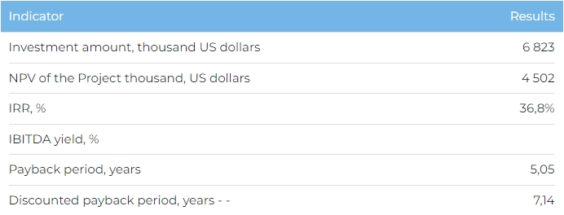Products

The plant is due to be commissioned in 2025 and full capacity reached in 2030. Annual sales volumes will amount to 48,960 thousand units of toilet paper rolls per year, 4,680 thousand units of jumbo rolls per year, 2,376 thousand units of paper towels per year. The Company plans to sell 80% of its product in in Kazakhstan and export the remainder to other CIS countries.

Project

The project envisages the construction of a factory to produce paper products in Aktobe Industrial Zone in Aktobe region. At the moment, a 1.7 ha has been leased in the Aktobe region. Discussions are being held with equipment suppliers from China.

Project Initiator

Lucrum Star LLP was created in 2018 and owns the Mereke, Romashka, Sakura and Jumbo sanitary paper product brands. Current company production unit capacity is 3,335 tonnes of base paper per year, which is the equivalent of 23 million rolls of toilet paper.

Market Overview

The global paper product market was worth 563.53 billion USD in 2022. The Business Research Company is predicting that it will be worth 760.31 billion USD by 2027. The sanitary paper product market accounted for 10% (55.9 billion USD) of the total paper product market in 2022.
In 2022, sanitary paper product production in Kazakhstan was worth 68.5 million tonnes, which is 16% lower than in 2021. CAGR for production in 2018-2022 was -0.29%.
Exports of sanitary paper products increased from US$ 9.9 billion in 2018 up to US$ 11.8 billion in 2022 at a CAGR of 4%.
Imports of sanitary paper products increased from US$ 10.5 billion in 2018 to US$ 12.1 billion in 2022 with CAGR of 4%.
What is the attractiveness of the project?
Advantageous location. Basing production in Aktobe Oblast secures access to a well-developed and extensive rail and road system that enables the delivery of both raw materials as well as finished products to neighbouring regions and CIS countries. The Project location also provides access to a large sales market. Aktobe Oblast is home to over 535 thousand persons, while the population of Aktobe, the region’s administrative centre is 222 thousand. The population of the neighbouring Mangistau, Atyrau and West-Kazakhstan Oblasts is roughly 2.1 million.
Production expansion. The Company owns the Mereke, Romashka, Sakura and Jumbo sanitary paper product brands. The factory will help supply the domestic market with quality product and reduce sanitary paper product imports into Kazakhstan, which accounted for 39% of total consumption (16,823 tonnes) in 2022.
Investment proposal

The Project requires investment of US$ 6,823 thousand, of which:
70% (US$ 4,776 thousand) – investor participation;
30% (US$ 2,047 thousand) – initiator’s own funds
The proposed financing structure and state support measures are indicative. The final financing structure and Project interests will be determined based on the results of negotiations with the investor.
