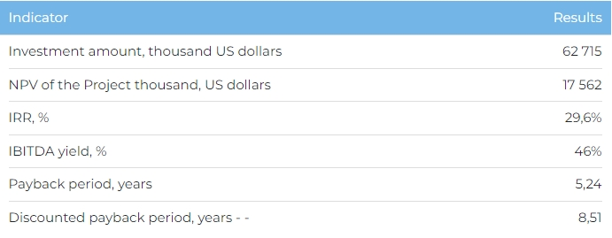

**Product**

At full capacity, which is planned for 2027, the plant will be producing: caustic soda 47% – 36,000 tonnes; caustic soda 100% – 18,000 tonnes; hydrochloric acid (33% solution) – 54,000 tonnes; sodium hypochlorite – 3,906 tonnes.

100% of product is due to be sold domestically in Kazakhstan.

**Project**

This investment project (the “Project”) covers the second phase of the construction of a 124,700 tonne/year caustic soda and chlorinecontaining product production plant on an 11 ha site in the “Aktau Seaport” Special Economic Zone in Aktau, Mangistau Oblast. Phase 1, which has been completed, involved the construction of calcium chloride facilities and the 411 m railway branch No. 1.

**Initiator**

Topan Chemical Industries LLP is a subsidiary of Topan LLP, specialising since 1999 in the production of laboratory equipment, processing solutions and gases, as well as water treatment coagulants. The Company also has a well-developed client base, which includes Tengizchevroil LLP, JSC Caspian Pipeline Consortium, JSC NC KazMunaiGas, JSC KazTransOil and JSC CNPC-Aktobemunaigas. Topan LLP owns production sites in Uralsk (4.5 ha) and Aksai (1.5 ha).

**Market**

* In 2022, the global caustic soda market was valued at 45 billion USD. According to Fortune Business Insights, the market is projected to reach 55.6 billion by 2027. The market is expected to grow at a CAGR of 4.3% between 2023 and 2027.
* The volume of the world market of hydrochloric acid amounted to 2.5 billion USD in 2022. The global hydrochloric acid market is expected to reach 3.4 billion USD by 2027 at CAGR (2023-2027) – 6.34%.
* The average annual rate of decline in the production of caustic soda in Kazakhstan for the period 2018-2022 amounted to 3.7%. The share of imports in the market is 59.7%. In Kazakhstan, the only major producer of caustic soda is Caustic JSC.

**What is the advantages of the project?**

**Advantageous location.** Having production based in Aktau will help give access to a consumer market of over 560 industrial companies in the local oblast. Access to a well-developed and extensive rail, road and sea transport network will aid the supply of feedstock and product exports. As a SEZ member, the Company may be eligible for tax and customs concessions, reduced land use charges, and a simplified procedure for employing overseas nationals.

**Company experience.** The Initiator parent company has been specialising since 1999 in laboratory equipment production, processing solutions and gases, as well as water treatment coagulants. Topan LLP owns production sites in Uralsk (4.5 ha) and Aksai (1.5 ha). It also has a well-developed client base, which includes Tengizchevroil LLP, JSC NC KazMunaiGas, JSC KazTransOil, JSC Caspian Pipeline Consortium and JSC CNPCAktobemunaigas.

**Project location Investment and financing structure**

The Project requires investment of 62,715 thousand USD (exchange rate: KZT 449), of which:

* 70% (43,900 thousand USD) – debt financing subject to collateral;
* 30% (18,814 thousand USD) – investor participation.

The proposed financing structure and state support measures are indicative. The final financing structure and Project interests will be determined based on the results of negotiations with the investor.

