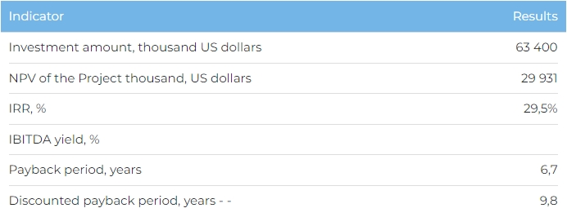
Products
Full design capacity, which is due to be reached in 2028, should equate to the following annual sales: unpainted profile – 18,150 thousand tonnes, painted profile – 11,880 thousand tonnes and anodised profile – 1,320 thousand tonnes.
All product is due to be sold domestically in Kazakhstan. In the long term, the company is also considering the possibility of exporting its products to the countries of Central Asia, the CIS, and Europe.
Project
This investment project envisages the construction of a plant to produce 31 thousand tonnes of extruded aluminium alloy products per year in the city of Pavlodar. For the purposes of the Project, the Initiator is planning to purchase a 13.5 ha site close to the raw material supplier – the Pavlodar Aluminium Plant.
The Company has signed a contract with JSC Aluminium Kazakhstan to supply aluminium product raw materials, as well as strategic agreements have been signed for product sales to construction companies.
Project Initiator
ALPROF LLP is a manufacturer of aluminum profiles with state licenses №15020306 from 19.11.2015 for legal entities to collect (procure), store, process and sell ferrous and non-ferrous metal scrap and waste and №17004299 from 10.03.2017 for category 3 project activities. Since 2003, the Company has sold over 60 thousand tonnes of product and completed 1 thousand construction projects in Kazakhstan. The Company’s Almaty plant produced 7.2 thousand tonnes of product in 2022. The Company's products are certified for compliance with ISO 9001 quality standard.
Market Overview
- As of 2022, the volume of consumption of profiles and similar products made of ferrous metals or aluminum in the Republic of Kazakhstan amounted to 234 thousand tonnes, which is 2% higher than in 2021.
- In 2022, import of other aluminum alloy profiles in Kazakhstan amounted to 19.3 mln USD and were mainly came from Russia (74%).
- In 2022, the volume of the construction industry of the Kazakhstan amounted to 13.6 bln USD. According to Marketline, the construction industry of the Republic of Kazakhstan in 2023-2026 will grow at an average annual rate of 8%.
What is the attractiveness of the project?
- Advantageous location. Having production based in the city of Pavlodar will provide access to the consumer markets of Pavlodar Oblast, Astana, Abai, North-Kazakhstan, Akmola and Karaganda Oblasts, which are home to over 3 thousand construction sector organisations. In addition, access to a well-developed and extensive rail and road system will help manage both raw material and plant finished product deliveries. Proximity to the source of raw materials (Pavlodar Aluminium Plant) will reduce transportation and overhead costs, and also improve production performance.
- Capacity increases and new sales markets. Access to resources and the use of innovative processing technology will help increase production capacity and vary the Company’s product range, which will enable it to develop new markets.
Investment proposal
The Project requires investment of 63,400 thousand USD (at the rate of 449.2 tenge), of which:
- 70% (44,380 thousand USD) - debt financing subject to collateral;
- 30% (19,020 thousand USD) – investor participation.
The proposed financing structure and state support measures are indicative. The final financing structure and Project interests will be determined based on the results of negotiations with the investor.

