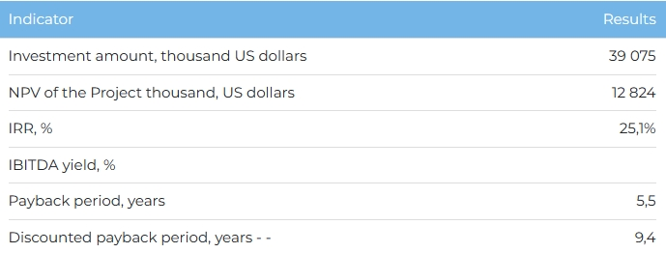

**Products**  
  
Commissioning is scheduled for 2025, and reaching the design capacity - for 2026. Upon reaching full capacity, annual sales volumes will amount to 450 thousand cubic meters. m per year. 25% of the volume of aerated concrete products is planned to be sold on the domestic market, 75% - in neighboring countries (Russia, Uzbekistan, Azerbaijan and Georgia).  
  
**Project**  
  
The project provides for the construction of a plant for the production of aerated concrete blocks and reinforced slabs on the territory of the Industrial Zone "Ondiris" in the village. Kyzylzharma, Kyzylorda region. At the moment, the Initiator has filed an application for a license for the subsoil use of the resource base at Cape Saryshoky-Zapadny. The explored deposit of quartz sands is located in the Aral district of the Kyzylorda region, has reserves of quartz sand of 10.5 million tons and is planned to be used by the Initiator for the extraction of the main raw material for the production of aerated concrete.  
  
**Company**  
  
LLP "Orda Porenbeton" is a company for the construction of a plant for the production of autoclaved aerated concrete.  
  
**Market**

* The global market for the production of cement and reinforced concrete products in 2022 amounted to $364.2 billion in value terms. Average annual growth rate of world cement exports for the period 2022-2027 forecasted at 7.7%. It is expected that by 2027 . the global market for cement and concrete products will reach 527.8 billion US dollars, an increase of 44.9% compared to 2022.
* In 2022, ready-mixed concrete accounted for 55% of the total global market for cement and concrete products, while concrete products and cement accounted for 20% and 15%, respectively.
* Imports of aerated concrete products to Kazakhstan increased from $1,948 thousand in 2018 to $2,728 thousand in 2022, with an average annual growth rate of 9%.
* Exports of aerated concrete products from Kazakhstan increased from $148,000 in 2018 to $475,000 in 2022 at an average annual growth rate of 34%.

**What is the attraction of the project?**

* **Product sustainability.** Autoclaved aerated concrete products are characterized by low energy consumption and high thermal insulation properties, which helps to reduce energy costs for space heating and cooling.
* **Advantages of production technology.** It is planned to use the autoclave method of aerated concrete production at the plant, which allows to reduce energy consumption by 2 times compared to the foaming method.
* **Availability of state support measures.** The production of aerated concrete is a priority sector of the economy of the Republic of Kazakhstan, for which benefits and economic conditions are provided to reduce the financial burden of enterprises within the framework of the following programs: "The Economy of Simple Things", the Concept for the Development of the Manufacturing Industry of the Republic of Kazakhstan for 2023 - 2029.

**Investment proposal**

For the implementation of the Project, financing in the amount of 39,075 thousand US dollars (at the rate of KZT/USD 446 tenge) is required, including:

* 70% (USD 27,352 thousand) - debt financing (subject to collateral);
* from 30% (USD 11,722 thousand) - investor participation.

The proposed financing structure and state support measures are indicative, the final financing structure and the stake in the Project will be determined based on the results of joint negotiations with the investor.

