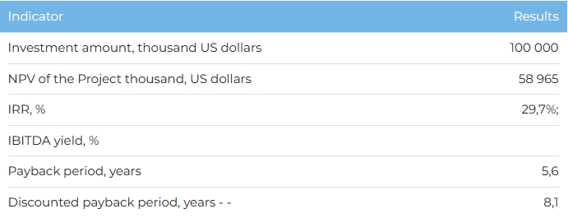

**Products**  
  
The entire volume of cement products is planned to be sold on the domestic market. Commissioning is scheduled for 2026, and reaching the design capacity in 2027. Upon reaching full capacity, annual sales volumes will amount to 1 million tons of cement.  
  
**Project**  
  
The project provides for the construction of a plant for the production of cement on its own raw material base with a capacity of 1 million tons per year on the territory of the Taskalinsky district of the West Kazakhstan region (WKO). For the implementation of the Project, the akimat of the Taskalinsky district of WKO has allocated a land plot of 60 hectares with the right of private ownership. The initiator has the appropriate licenses for the geological study of the subsoil of the groundwater deposit and the extraction of raw materials (No. 013/19, No. 014/19, No. 015/19 dated January 18, 2019 for chalk, clay rocks and flask, respectively) for 25 years with the right subsequent renewal after the expiration of the contracts. For the extraction of chalk, clay raw materials and flasks, the akimat of the Taskala district of the WKO also allocated to the Initiator the corresponding land plots of 145 hectares, 145 hectares and 76 hectares for the period until January 18, 2044.  
  
**Company**  
  
SpetsStroyService LLP is a construction company with a state license of the 1st category No. 17005273 dated March 28, 2017 for construction and installation work. The company was the general contractor at the social facilities of Karachaganak Petroleum Operating B.V. (KPO B.V.), Zhaikteploenergia JSC, GKP Vodokanal, etc.  
  
**Market**

* According to a report by the Bureau for National Statistics, the volume of the construction industry in Kazakhstan has grown annually at a CAGR of 9% over the period 2018-2022. At the same time, Marketline predicts that the construction industry in Kazakhstan in 2023-2026. will grow at an average annual growth rate of 8%.
* According to the Bureau of National Statistics of the Agency for Strategic Planning and Reforms of the Republic of Kazakhstan, in 2022, 12,088 thousand tons of Portland cement were produced. In the period 2018-2022 Portland cement output increased by 23%. The average annual growth rate of production volumes for the period 2018-2022 reached 4%.

**What is the attraction of the project?**

* **Availability of own raw material base.**The project is based on its own raw material base, which will reduce the cost of production, ensure the proper quality of products at a competitive price. The initiator has the appropriate licenses for the geological exploration of the subsoil of the groundwater deposit and the extraction of raw materials for 25 years with the right to further prolongation after the expiration of the contracts.
* **Advantages of production technology.** It is planned to use the dry method of Portland cement production at the plant, which allows to reduce energy consumption costs by 2 times compared to the wet method.
* **Governmental support.** The project belongs to priority investment projects, for which state preferences are provided. Participation in a number of state programs for obtaining tax preferences, subsidies, concessional lending will reduce capital costs and increase the profitability of production.

**Investment proposal**  
For the implementation of the Project, financing in the amount of 100,000 thousand US dollars is required (at the rate of 449.2 tenge):

* 70% (USD 70,000 thousand) - debt financing (subject to collateral);
* 30% (USD 30,000 thousand) - investor participation.

The proposed financing structure and state support measures are indicative, the final financing structure and the stake in the Project will be determined based on the results of joint negotiations with the investor.

