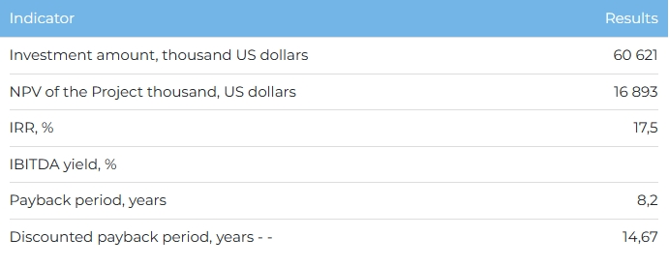

**Products**  
  
The project will make it possible to supply electricity to the projected production of lithium concentrate of Alatau Litiy LLP. The average annual power generation capacity will be 128 million kWh.

**Project**  
  
The project provides for the construction of a cascade of five hydroelectric power plants (HPP) with an installed capacity of 32.8 MW on the Bayynkol River in the Rayymbek district of the Almaty region. The maximum power generation capacity is 160.9 million kWh. The full launch of the entire HPP cascade is planned for 2027. The HPP cascade is implemented according to the single-line hydrotechnical scheme "hydroelectric complex - diversion canal - water conduit - unit - power output" and will consist of no more than 3 hydraulic units at each HPP, depending on the type of turbine chosen , with power output to open switchgear (ORG) 35 kV. A resolution of the Akimat was received on the allocation of a land plot with an area of 171.5 hectares for the construction of a cascade of hydroelectric power stations. There is an approved power distribution scheme for a cascade of power plants, technical specifications, other permits and approvals have been obtained.  
  
**Company**  
  
The Project initiator is Alatau Hydro Cascade LLP. The company was established in 2019 for the construction of hydroelectric power plants, power generation and does not have an operating business.  
  
**Market**

* Electricity generation in the Republic of Kazakhstan is carried out by 207 power plants of various forms of ownership. As of 01/01/2023, the total installed capacity of the power plants of the Republic of Kazakhstan amounted to 24,523.7 MW, and the available capacity was 20,761.7 MW.
* In 2023-2029 a shortage of electricity in the Republic of Kazakhstan is forecasted at the level of 1.22 billion kWh. By 2029, over 80% of electricity (115 billion kWh) will be provided by existing capacities, while about 26 billion kWh is planned to be provided through the construction of new power plants.
* In 2022, electricity consumption in the Almaty region amounted to 11,442 million kWh, with production of 6,651 kWh. About 56% of the generating equipment of power plants is over 30 years old, and physical deterioration reaches 60%.

**What is the attraction of the project?**

* **Environmental Safety.**The generation of electricity at a hydropower plant significantly reduces the amount of harmful emissions into the environment with minimal water consumption, and the used water is discharged back into the river through the flow part of the turbines (or is used to generate electricity in a downstream HPP of the cascade).
* **Contract work.**Today,the Company has an official letter of consent from the main consumer LLP "Alatau Lithium" for the purchase of electricity.
* **Reliability of the raw material base.** The raw material for the production of electricity is the water runoff of mountain rivers. Precipitation levels in the catchment area are relatively stable and the risk of reduced river flows is assessed as minimal.
* **State support.**The renewable energy (RES) sector is actively supported by the state. To date, enterprises in the renewable energy sector are exempted from paying for electricity transmission services, they are provided with predictable and long-term tariffs and a guaranteed purchase of all generated electricity.

**Investment proposal**  
For the implementation of the Project, financing in the amount of 60,261 thousand US dollars (at the rate of 449.2 tenge) is required, of which:

* 70% (USD 42,435 thousand) - debt financing (subject to collateral);
* 30% (USD 18,186 thousand) - investor participation.

The proposed financing structure and state support measures are indicative, the final financing structure and the stake in the Project will be determined based on the results of joint negotiations with the investor.

