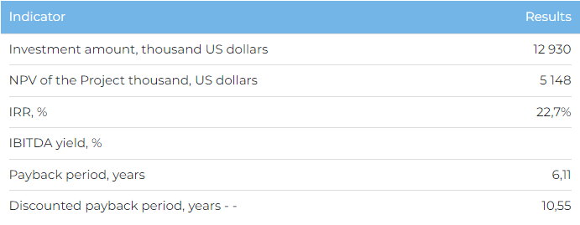

**Products and services**  
  
The center will offer its services to residents and guests of the Almaty region, Almaty city, Zhetisu region, as well as foreign tourists. When reaching full design capacity with a hotel room stock of 400 rooms, it is planned to serve more than 70,000 visitors annually. The center plans to provide clients with accommodation services (hotels and lodges), services of a restaurant complex, wellness treatments, rental of ATVs and snowmobiles, as well as a ski complex serving up to 12,000 visitors per year.  
  
**Project**  
  
It is planned to build a health center on the coast of the lake. Alakol in the village Koktuma region of Zhetisu. The center provides a wide range of tourist services for family and active recreation, recreation for adults, as well as health, corporate and sports recreation. The project will be implemented on land plots of 4 hectares and 20 hectares for the construction of hotels and guest houses, as well as a ski base, respectively, located 70 km (50 minutes by car) from Usharal. In addition, the Center will have a restaurant, an indoor water park with three swimming pools, a spa, a gym and a tennis court.  
  
**Company**  
  
The initiator of the Project is Shoqai Best LLP. The founder of the Company has 17 years of experience in the tourism industry, including the management of the Aswan recreation area in the Zhetisu region.  
  
**Market**

* In 2020, the volume of the tourism industry of the Republic of Kazakhstan decreased by 34.2% compared to 2019 and amounted to 7.7 billion US dollars. The main reason for the fall was the COVID-19 pandemic and the quarantine measures introduced. After the pandemic, the market grew by 23.4% in 2021 and 17.9% in 2022.
* According to Kazakh Tourism, in 2021 Kazakhstan took 66th place out of 117 countries in the World Travel and Tourism Development Index, ahead of Montenegro (67), Morocco (71), Kyrgyzstan (90). According to Marketline forecasts, by 2027 the size of the tourism market in Kazakhstan in value terms will be $16.7 billion, an increase of 49% compared to 2022.
* Alakol resort area (Zhetisu region) is one of the popular resort areas in the Republic of Kazakhstan, the cumulative average annual growth rate in the number of visitors for 2017-2022. amounted to 18%.

**What is the attraction of the project?**

* **Attractive location and year-round offer.** The location is attractive for a year-round offer, including hotel accommodation, ski resort, indoor water park and other types of recreation. The center is located within a three-hour car accessibility from the city of Taldykorgan and 641 km from the largest city of the country - Almaty. The resorts located in the region are mainly focused on the spring-summer period; there are no high-altitude ski facilities in the region. There is an internal potential for the development of niche tourism in the Zhetisu region due to its natural characteristics. Mud treatments on Lake Alakol are known in the treatment of skin diseases and the prevention of colds due to useful minerals, hydrogen sulfide and sodium chloride salts.
* **Governmental support.**The tourism industry in the country is actively supported by the state. State support measures include reimbursement of part of the costs for the purchase of equipment and the construction of tourist facilities.

**Investment proposal**  
  
The Project implementation requires financing in the amount of 12,930 thousand US dollars (at the rate of KZT/USD 449.2 tenge), including:

* 100% (USD 12,930 thousand) – investor participation.

The proposed financing structure and state support measures are indicative, the final financing structure and the stake in the Project will be determined based on the results of joint negotiations with the investor.

