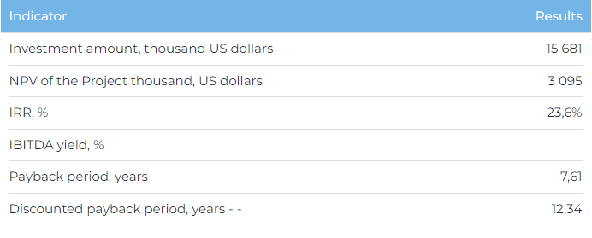

**Product**

The Project is scheduled to be commissioned by 2024, reaching the full capacity - in 2028. Upon reaching the full capacity, the annual production volumes will be as follows: sale of apples - 6,935 tonnes; apple storage lease - 2,290 tonnes. 20% of the products is planned to be sold in the markets of Russia, 80% will be sold in Kazakhstan.

**Project**

This Project ("Project") plans to build a fruit storage facility with a capacity of 9,225 tonnes on an area of 3.8 ha in Almaty region. The Project will also build a sorting and packaging complex. The company plans to get a land plot for rent in the Almaty region within the framework of the Project. Almaty region has a favorable location in terms of production capabilities and availability of transport communications for prompt delivery of finished products to the regions of Kazakhstan with subsequent access to foreign markets. Another advantage of the Project location is its proximity to consumer markets. As of April 2023, the combined population of Almaty region and the city of Almaty exceeds 3.7 million people.

**Initiator**

ISSYK FOOD LTD is a project company established for the construction of a fruit storage facility.

**Market**

* International purchases of imported apples in 2022 amounted to 12.5 million tonnes. The average annual growth rate of global imports from 2018-2022 was 11.4%. Russia was one of the largest importers of fresh apples in 2022.
* In 2022, 268 thousand tonnes of apples were harvested in Kazakhstan. The average annual apple harvest over the period 2017-2022 was about 235 thousand tonnes, and the average annual growth rate (CAGR) was 8.2%. The consumption of apples in the RK over the last 5 years shows a steady growth with an average of 337 thousand tonnes. In 2017 - 2022, the average annual growth rate of product consumption was 4%. The leaders in fruit consumption are Almaty city (88.9 kg), Mangistau region (87.5 kg) and Astana city (85.2 kg).

**What is the advantages of the project?**

**Advantageous location.** Location of the fruit storage is assumed in Almaty region, where the production of apples is widely developed. According to the results of 2022, the total planted area for apples in the region was 11,139 ha, the annual harvest of apples - 94.9 thousand tonnes.

**Advanced, waste free and eco-friendly processing.**Ripe apples that do not meet the standard for sale fresh are used in the processing industry for products such as jams, juices, apple puree, pectin.

**Quality of goods sold.**The company uses Control Atmosphere Storage Technology, which preserves fruit texture and color for up to 11 months (instead of 6 months).

**State support.**The Project is included in the list of priority sectors for State support, under which a range of benefits, preferences, and in-kind grants can be obtained.

**Investment and financing structure**

The Project requires investment of US$ 15,681 thousand (exchange rate: KZT 449), of which:

* 70% (US$ 10,977 thousand) – debt financing subject to collateral;
* 30% (US$ 4,704 thousand) – investor participation.

The proposed financing structure and state support measures are indicative. The final financing structure and Project interests will be determined based on the results of negotiations with the investor.

