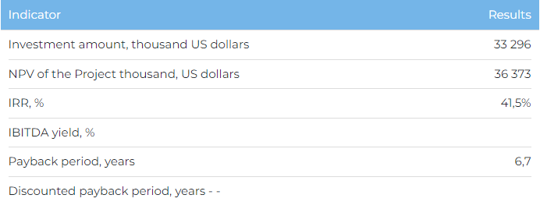

**Products**  
  
It is planned to reach the design capacity (up to 20 thousand units annually) in 2027. It is planned to sell finished products in the domestic and foreign markets (Kyrgyzstan and Uzbekistan).  
  
**Project**  
  
The Project involves the construction of a plant for the production of electrocardiographs (medical equipment) in the Special Economic Zone "Astana-Technopolis" in Astana.  
  
The following tasks will be solved within the framework of the Project:

* effective import substitution through the production of high-quality electrocardiographs;
* creation of about 120 additional jobs in the region.

**Company**  
  
LLP "Telemedical Center" Sapa "since 2016 has been carrying out activities for the production and sale of telemetric medical equipment. The company is the only developer and manufacturer of telemetric electrocardiographs in Kazakhstan.  
  
**Market**

* The worldwide demand for ECG devices is expected to grow as they provide a user-friendly interface through which information can be exchanged through Cardiovascular Information Systems (CIS). According to BIS Research estimates, the compound annual growth rate (CAGR) of the ECG telemetry market in the period 2021-2030 is . will be 5.6%.
* According to the Ministry of Health of the Republic of Kazakhstan, there are prerequisites for an increase in demand for electrocardiographs in the country. This is due to the high prevalence of pathology associated with diseases of the circulatory system.

**What is the attraction of the project?**

* **Experience of the Initiator and distribution channels.** The company has many years of experience in the production and sale of telemetric medical equipment. The company has a patent for the production of its products and has passed the ISO-13485 quality management certification for the production of medical products. The KZM telecardiograph manufactured by the Company is used in private and public medical organizations, PHC and ambulance services of the Republic of Kazakhstan.
* **Governmental support.**The project is included in the list of priority sectors for state support, within the framework of which it is possible to receive a number of benefits, preferences and in-kind grants. Companies, as a participant in the SEZ, are provided with a long-term lease of a land plot provided with engineering and technical communications, as well as preferences for taxes and customs payments, benefits for utility bills.

**Investment offer**  
  
To implement the Project, funding in the amount of USD 33,296 thousand is required, including:

* 70% (USD 23,307 thousand) - debt financing (subject to collateral);
* from 30% (USD 9,989 thousand) - investor participation.

The proposed financing structure and state support measures are indicative, the final financing structure and the stake in the Project will be determined based on the results of joint negotiations with the investor.

