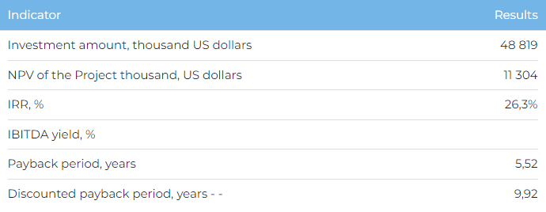

**Products**

At full design capacity in 2027, sales volumes of brick tiles will reach 1,000,000 m2 . 60% of product is due to be sold domestically, and the remainder exported to Russia, Uzbekistan and Kyrgyzstan.

**Project**

The project envisages the construction of a plant to produce 1 million m2 of ceramic products per year in the city of Karaganda. The initiator has received license No. 2034-EL dated 5 June 2023 to explore common minerals (clay) for 6 years, with an option to extend. It is also working on receiving licenses to produce clay at the Saransk field, site No. 1 (18 km from the plant) in Karaganda Oblast and Tankeris field (270 km from the plant) in Akmola Oblast.

**Project Initiator**

QAZCLINKER LLP was founded in 2022 to realise a project to build a plant producing brick tiles in Kazakhstan. Key company staff have been involved in the construction of a brick plant in Kazakhstan at SG Brick LLP with capacity of 120 million units per year for the company G-park.

**Market Overview**

* According to the National Statistics Bureau, the Kazakhstan construction sector grew annually at an average annual rate of 9% between 2018 and 2022. At the same time, Marketline is predicting that the Kazakhstan construction sector will grow in 2023-2026 at an average annual rate of 8%.
* In 2022, the total area of building facades in Kazakhstan was 13,207 thousand m2, with CAGR for 2018-2022 at 5%.
* Consumption of bricks, tiles and building products made from baked clay in the Kazakhstan in 2022 amounted to 140,490 thousand USD (CAGR for the period 2018-2022 was 28%).
* In 2022, exports of ceramic bricks, blocks, tiles made from silica stone flour from the Kazakhstan amounted to 58 tonnes, and imports – 23,143 tonnes.

**What is the attractiveness of the project?**

* **Advantageous location.** Karaganda Oblast has a raw materials production base. Its own raw materials base will help reduce production costs and ensure quality product is supplied at competitive prices.
* **State support.**The Project is recognised as a priority sector for state support, which takes the form of concessions and land grants. Current state support programmes for residential construction in Kazakhstan (“Bakytty Otbasy” and “5–10–20”), as well as the development of infrastructure and transport systems help increase demand for construction materials, including ceramic products.
* **Professional Project team.** Key Company personnel have 10 years of construction sector experience. The Project team has also entered into strategic product sales agreements with distribution companies Asia Klinker LLP (11,500 thousand units) and ASG LLP (400 thousand m2 per year), and also to supply 160 thousand m2 of tiles annually to the RGB Group LLP construction company.

**Investment proposal**

The Project requires investment of 48,819 thousand USD (at the rate of 449.2 tenge), of which:

* 85% (USD 41,496 thousand) – debt financing subject to collateral;
* 15% (USD 7,323 thousand) – own funds.

The proposed financing structure and state support measures are indicative. The final financing structure and Project interests will be determined based on the results of negotiations with the investor.

