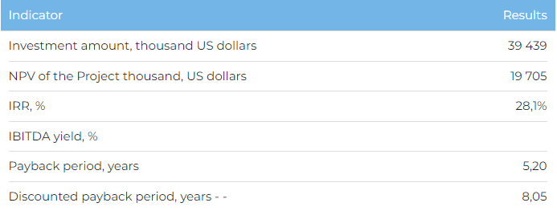

**Products**  
  
Commissioning of the Project is scheduled for 2025, reaching the design capacity in 2026. Upon reaching full capacity, the annual production of fiber cement boards will be 33,500 tons per year. The following product range is planned: 6 mm - 28,475 tons and 8 mm - 5,025 tons. The entire volume of finished products is planned to be sold on the domestic market.  
  
**Project**  
  
This investment project (“Project”) provides for the construction of a plant for the production of fiber cement products with a capacity of 33,500 thousand tons per year on the territory of the Ondiris Industrial Zone in the village. Kyzylzharma, Kyzylorda region. Finished products are planned to be sold in Kazakhstan. Raw materials for the production of fiber cement are planned to be obtained from the Saryshoky quartz sand deposit located in the Kyzylorda region. The company is working to obtain an appropriate license for the right to subsoil use for the specified field. Samga Eurotrade LLP is a design company established for the construction of a plant for the production of fiber cement products.  
  
**Market**

* In 2021, the value of the global fiber cement market was $15,229.9 million. According to Market Research Future forecasts, by 2028 this figure will reach 21,393.2 million USD, an increase of 40.4% compared to 2021. The average annual growth rate of the market in the period 2021-2028. forecasted at 4.97%.
* The average annual growth rate of imports of fiber cement products in the Republic of Kazakhstan for the period 2018-2022 amounted to 26.9%, reaching USD 11.5 million in 2022. In 2022, fiber cement products were imported mainly from Lithuania (75%) and Belgium (18%).
* According to Trade Map data, the volume of exports of fiber cement products from the Republic of Kazakhstan for the period 2018-2021. was immaterial ($6,000 in 2021). Products were supplied to Germany (90%) and Russia (10%). Today, fiber cement boards are a relatively new finishing material on the Kazakhstani market, and its production in Kazakhstan is at the initial stages of development.

**What is the attraction of the project?**  
  
**Advantages of production technology.**The plant will apply advanced energy-saving production technologies, as well as a system for collecting and analyzing data from the production process, which will optimize the production process.  
  
**Environmental friendliness and fire resistance of products**. Fiber cement products are fully environmentally friendly and can be completely recycled in the environment. Products comply with the RoHS directive, which regulates the content of heavy metals in the product. In addition, the products have high thermal conductivity from 0.217 to 0.430 W/m°K, which also indicates their high fire resistance.  
  
**Availability of state support measures.** The production of fiber cement products is a priority sector of the economy of the Republic of Kazakhstan, for which benefits and economic conditions are provided to reduce the financial burden of enterprises within the framework of the following programs: "The Economy of Simple Things", the Concept for the Development of the Manufacturing Industry of the Republic of Kazakhstan for 2023 - 2029.  
  
**Investment proposal**  
  
The Project requires financing in the amount of USD 39,439 thousand:

* 70% (USD 27,607 thousand) - debt financing (subject to collateral);
* from 30% (USD 11,832 thousand) - investor participation.

The proposed financing structure and state support measures are indicative, the final financing structure and the stake in the Project will be determined based on the results of joint negotiations with the investor.

