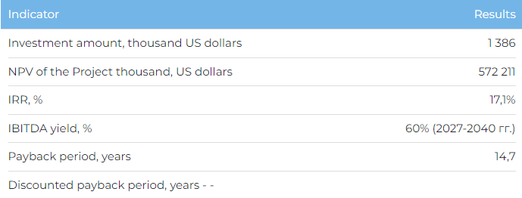

**Products**  
  
Planned sales volumes by types of products:

* ammonium nitrate - 500,000 tons / year;
* carbamide - 577,500 tons/year;
* ammonia - 108,000 tons/year.

The company plans to sell products both on the domestic market and for export to Western Europe, Southeast Asia (Indo-China), the USA, Mexico and Brazil.  
  
**Project**

* Within the framework of the Project, it is planned to build an ammonia-urea complex in the Mangistau region in the industrial zone No. 6 of Aktau, adjacent to the territory of the operating site of KazAzot JSC.
* The project will increase production volumes to meet the needs of domestic demand, as well as ensure the export of ammonia and ammonium nitrate. In addition, the Project provides for the diversification of production with the release of a new nomenclature for Kazakhstan - urea. The new production will create 913 new permanent and 1,500 temporary jobs.

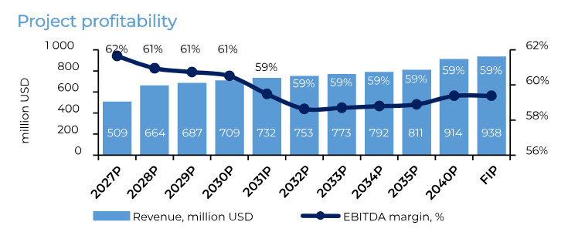

**Company**

* JSC "KazAzot" is the only plant in Kazakhstan for the production of ammonia and ammonium nitrate and the main supplier for most agricultural producers.
* Delivery of the company's products is carried out in more than 15 countries of Eurasia.
* The company has a vertically integrated production process, from the extraction of raw materials to its deep processing, and mainly by its own power generation.

**World market**

* According to The GrandViewResearch, in 2030 the global market for nitrogen fertilizers will be worth $94.02 billion.
* In 2021, more than 44% of nitrogen fertilizers worldwide were used for growing cereals and grains.

**What is the attraction of the project?**

* **Availability of raw material base.**The company produces natural gas from its own ShagyrlyShomyshty field. The Company also has a contract with the Ministry of Energy of the Republic of Kazakhstan for the exploration and production of hydrocarbon materials at the Kosbulak field. Gas production from our own field significantly reduces the cost of ammonia and nitric acid production.
* **Developed infrastructure and brand awareness in foreign markets.**The projected complex is planned to be built on the territory near the operating plant of KazAzot JSC, which allows to take advantage of the ready and developed infrastructure, including a fleet of railway tanks for the transportation of ammonia, well-established production and operational processes. The Company's products are recognizable in foreign markets, have passed the appropriate registration in the EU, Russia, Ukraine, Georgia and Azerbaijan.

**Investment proposal**  
  
The Project implementation requires financing in the amount of USD 1,386,157 thousand, including:

* 90% (USD 1,247,541 thousand) - investor participation
* 10% (138,616 thousand US dollars) - own funds of KazAzot JSC.

The proposed financing structure and state support measures are indicative, the final financing structure and the stake in the Project will be determined based on the results of joint negotiations with the investor.